
AMERICAN INTERNATIONAL
UNIVERSITY-BANGLADESH
Faculty of Science and Technology

Assignment Cover Sheet

Assignment Title: | Allowance Management System
Assignment No: | Final Term Project |  | Date of Submission: | 14 May 2023
Course Title: | Introduction to Database
Course Code: | CSC 2107 |  | Section: | I
Semester: | Spring | 2022-23 | Course Teacher: | NUSRAT JAHAN ANANNYA

Declaration and Statement of Authorship:
- I/we hold a copy of this Assignment/Case-Study, which can be produced if the original is lost/damaged.
- This Assignment/Case-Study is my/our original work and no part of it has been copied from any other student’s work or from any other source except where due acknowledgement is made.
- No part of this Assignment/Case-Study has been written for me/us by any other person except where such collaborationhas been authorized by the concerned teacher and is clearly acknowledged in the assignment.
- I/we have not previously submitted or currently submitting this work for any other course/unit.
- This work may be reproduced, communicated, compared and archived for the purpose of detecting plagiarism.
- I/we give permission for a copy of my/our marked work to be retained by the Faculty for review and comparison, including review by external examiners.
- I/we understand thatPlagiarism is the presentation of the work, idea or creation of another person as though it is your own. It is a formofcheatingandisaveryseriousacademicoffencethatmayleadtoexpulsionfromtheUniversity. Plagiarized material can be drawn from, and presented in, written, graphic and visual form, including electronic data, and oral presentations. Plagiarism occurs when the origin of them arterial used is not appropriately cited.
- I/we also understand that enabling plagiarism is the act of assisting or allowing another person to plagiarize or to copy my/our work.

* Student(s) must complete all details except the faculty use part.
** Please submit all assignments to your course teacher or the office of the concerned teacher.

Group Name/No.: | 6

No | Name | ID | Program | Signature
1 | MD. AL-IMRAN SAYEM | 22-48023-2 | BSc [CSE]
2 | MD. FERDOUSE AHMED OLI | 22-47549-2 | BSc [CSE]
3 | AHSANUL EKRAM PATWARY | 22-46472-1 | BSc [CSE]
4 | MD. RAIHAN KABIR | 22-47554-2 | BSc [CSE]
5 |  |  | Choose an item.
6 |  |  | Choose an item.
7 |  |  | Choose an item.
8 |  |  | Choose an item.
9 |  |  | Choose an item.
10 |  |  | Choose an item.

Faculty use only
FACULTYCOMMENTS | Marks Obtained
 | Total Marks

OUTLINE

- COVER PAGE --------------------------------------------------------------------------------------- 01
- OUTLINE -------------------------------------------------------------------------------------------- 02
- SCENARIO ------------------------------------------------------------------------------------------ 03
- ER-DIAGRAM -------------------------------------------------------------------------------------- 04
- NORMALIZATION -------------------------------------------------------------------------- 05 – 10
- ALL TABLE ------------------------------------------------------------------------------------ 10 – 11
- FINAL TABLE --------------------------------------------------------------------------------- 11 – 12
- CREATE TABLE ------------------------------------------------------------------------------- 13 – 19
- INSERT VALUE ------------------------------------------------------------------------------- 20 – 29
- GROUP FUNCTION ------------------------------------------------------------------------------- 30
- SUB QUERY ----------------------------------------------------------------------------------- 30 – 31
- VIEW ------------------------------------------------------------------------------------------------- 32
- EQUIJOIN -------------------------------------------------------------------------------------------- 32

Scenario
In an ALLOWANCE MANAGEMENT SYSTEM, one or more INTERNATIONAL FUND donates to one or more NGO and RELIEF ORGANIZATIONS. INTERNATIONALS FUNDINGS have IFNAME, IFLOC, IFMOBILENO, IFFAMOUNT and a unique IFID. One or more people also donate to the NGO and RELIEF ORGANIZATIONS. The PERSON has PNAME, PMOBILENO, PLOC, PFAMOUNT and a unique PID. FUNDRISERS are also organized to collect fundings. FUNDRISERS have FRNAME, FRFAMOUNT, and a primary FRID. Some GOVERNEMNT FUNDS collect govt fund, have also GFNAME, GFFAMOUNT, and primary GFID. NGO have also NGONAME, NGOLOC, NGOLOC and a primary NGOID. RELIEF ORGANIZATIONS also have RORGNAME, RORGLOC, RORGMOBILENO and a primary RORGID. NGO helps fund RELIEF ORGANIZATIONS. The RELIEF ORGANIZATIONS distribute relief among one or more FARMERS and NATURAL DISASTER AFFECTED PEOPLE. NGO also distributes fundings ORPHANS, WIDOW, DISABLE and MATERNITY. ORPHANS, WIDOW, DISABLE and MATERNITY have ID, NAME, LOC and MOBILENO.

ER-Diagram
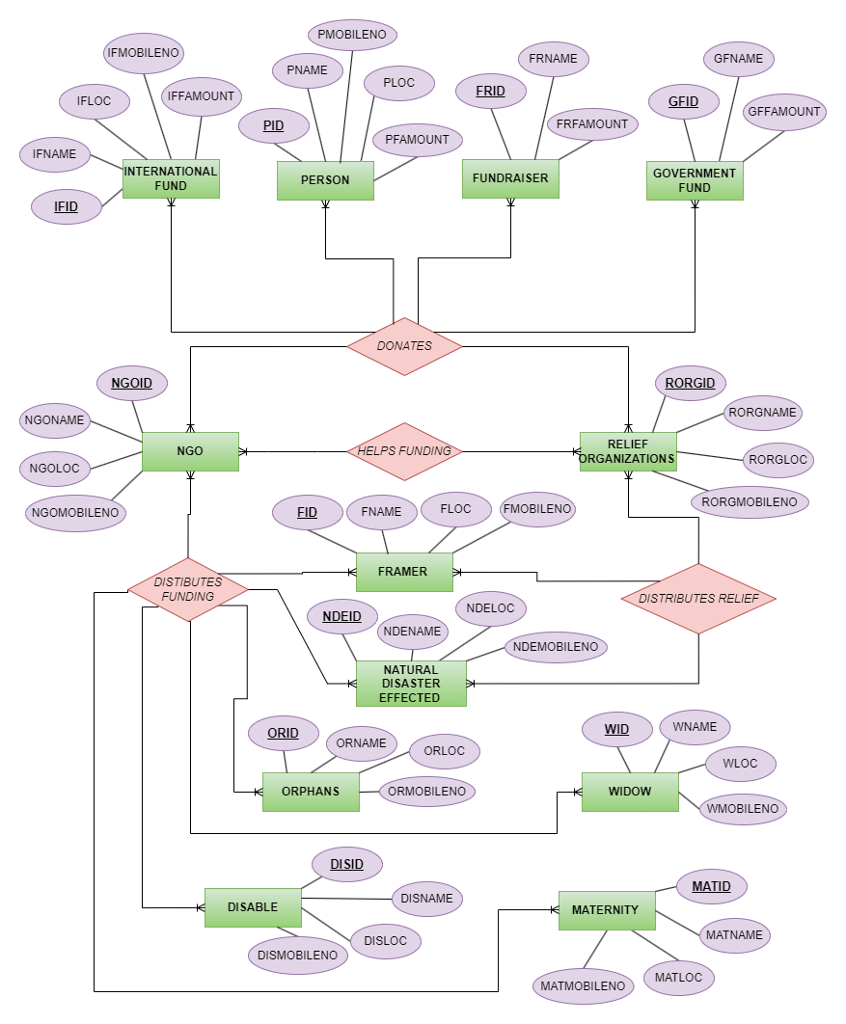
NORMALIZATION
- INTERNATIONAL FUND (1...*) DONATES (1...*) NGO
UNF: IFID, IFNAME, IFLOC, IFMOBILENO, IFAMOUNT, NGOID, NGONAME, NGOLOC, NGOMOBILENO
1NF: IFID, IFNAME, IFLOC, IFMOBILENO, IFAMOUNT, NGOID, NGONAME, NGOLOC, NGOMOBILENO
2NF:
- NGOID, NGONAME, NGOLOC, NGOMOBILENO
- IFID, IFNAME, IFLOC, IFMOBILENO, IFAMOUNT
3NF:
- NGOID, NGONAME, NGOLOC, NGOMOBILENO
- IFID, IFNAME, IFLOC, IFMOBILENO
- IFID, IFAMOUNT, *NGOID

- PERSON (1..*) DONATES (1..*) NGO

UNF: PID, PNAME, PMOBILENO, PLOC, PFAMOUNT, NGOID, NGONAME, NGOLOC, NGOMOBILENO
1NF: PID, PNAME, PMOBILENO, PLOC, PFAMOUNT, NGOID, NGONAME, NGOLOC, NGOMOBILENO
2NF:
- PID, PNAME, PMOBILENO, PLOC, PFAMOUNT
- NGOID, NGONAME, NGOLOC, NGOMOBILENO
3NF:
- PID, PNAME, PMOBILENO, PLOC
- PID, PFAMOUNT *NGOID
- NGOID, NGONAME, NGOLOC, NGOMOBILENO

- FUNDRISER (1..*) DINATES (1..*) NGO
UNF: FRID, FNAME, FRAMOUNT, NGOID, NGONAME, NGOLOC, NGOMOBILENO
1NF: FRID, FNAME, FRAMOUNT, NGOID, NGONAME, NGOLOC, NGOMOBILENO
2NF:
- FRID, FNAME, FRAMOUNT
- NGOID, NGONAME, NGOLOC, NGOMOBILENO
3NF:
- FRID, FNAME,
- FRAMOUNT, FRID, *NGOID
- NGOID, NGONAME, NGOLOC, NGOMOBILENO

- GOVERMENT FUND (1..*) DOANTES (1...*) NGO
UNF: GFID, GFNAME, GFFAMOUNT, NGOID, NGONAME, NGOLOC, NGOMOBILENO
1NF: GFID, GFNAME, GFFAMOUNT, NGOID, NGONAME, NGOLOC, NGOMOBILENO
2NF:
- NGOID, NGONAME, NGOLOC, NGOMOBILENO
- GFID, GFNAME,
- GFFAMOUNT, GFID, *NGOID
3NF:
- GFID, GFNAME,
- GFID, GFFAMOUNT , *NGOID
- NGOID, NGONAME, NGOLOC, NGOMOBILENO

- INTERNATIONAL FUNDS (1..*) DONATES (1..*)RELIEF ORGANIZATIONS
UNF: IFID, IFNAME, IFLOC, IFMOBILENO, IFAMOUNT, RORGID, RORGNAME, RORGLOC, RORGMOBILENO
1NF: IFID, IFNAME, IFLOC, IFMOBILENO, IFAMOUNT, RORGID, RORGNAME, RORGLOC, RORGMOBILENO
2NF:
- IFID, IFNAME, IFLOC, IFMOBILENO, IFAMOUNT
- RORGID, RORGNAME, RORGLOC, RORGMOBILENO
3NF:
- RORGID, RORGNAME, RORGLOC, RORGMOBILENO
- IFID, IFNAME, IFLOC, IFMOBILENO,
- IFID, IFAMOUNT, *RORGID

- PERSON DONATES (1..*) RELIEF (1...*)ORGANIZATIONS
UNF: PID, PNAME, PMOBILENO, PLOC, PFAMOUNT, RORGID, RORGNAME, RORGLOC, RORGMOBILENO
1NF: PID, PNAME, PMOBILENO, PLOC, PFAMOUNT, RORGID, RORGNAME, RORGLOC, RORGMOBILENO
2NF:
- PID, PNAME, PMOBILENO, PLOC, PFAMOUNT
- RORGID, RORGNAME, RORGLOC, RORGMOBILENO
3NF:
- PID, PNAME, PMOBILENO, PLOC,
- PID, PFAMOUNT, *RORGID
- RORGID, RORGNAME, RORGLOC, RORGMOBILENO

- FUNDRISER (1..*) DONATES (1..*) RELIEF ORGANIZATIONS
UNF: FRID, FNAME, FRAMOUNT, RORGID, RORGNAME, RORGLOC, RORGMOBILENO
1NF: FRID, FNAME, FRAMOUNT, RORGID, RORGNAME, RORGLOC, RORGMOBILENO
2NF:
- FRID, FNAME, FRAMOUNT
- RORGID, RORGNAME, RORGLOC, RORGMOBILENO
3NF:
- FRID, FNAME
- FRID, FRAMOUNT, *RORGSID
- RORGID, RORGNAME, RORGLOC, RORGMOBILENO

- GOVERNMENT FUND (1...*) DONATES (1...*) RELIEF ORGANIZATIONS
UNF: GFID, GFNAME, GFFAMOUNT, RORGID, RORGNAME, RORGLOC, RORGMOBILENO
1NF: GFID, GFNAME, GFFAMOUNT, RORGID, RORGNAME, RORGLOC, RORGMOBILENO
2NF:
- GFID, GFNAME, GFFAMOUNT
- RORGID, RORGNAME, RORGLOC, RORGMOBILENO
3NF:
- GFID, GFNAME,
- GFID, GFFAMOUNT, *RORGID
- RORGID, RORGNAME, RORGLOC, RORGMOBILENO

10. NGO (1...*) HELPS FUNDING (1...*) RELIEF ORGANIZATION
UNF : NGOID, NGONAME, NGOLOC, NGOMOBILENO, RORGID, RORGNAME, RORGLOC, RORGMOBILENO
1NF : NGOID, NGONAME, NGOLOC, NGOMOBILENO, RORGID, RORGNAME, RORGLOC, RORGMOBILENO
2NF :
- NGOID, NGONAME, NGOLOC, NGOMOBILENO,
- RORGID, RORGNAME, RORGLOC, RORGMOBILENO
3NF :
- NGOID, NGONAME, NGOLOC, NGOMOBILENO,
- RORGID, RORGNAME, RORGLOC, RORGMOBILENO, *NGOID

- RELIEF ORGANIZATIONS (1...*) DISTRIBUTE RELIEF (1..*) FARMER
UNF: RORGID, RORGNAME, RORGLOC, RORGMOBILENO, FID, FNAME, FLOC, FMOBILENO
1NF: RORGID, RORGNAME, RORGLOC, RORGMOBILENO, FID, FNAME, FLOC, FMOBILENO
2NF:
- RORGID, RORGNAME, RORGLOC, RORGMOBILENO
- FID, FNAME, FLOC, FMOBILENO
3NF:
- RORGID, RORGNAME, RORGLOC, RORGMOBILENO
- FID, FNAME, FLOC, FMOBILENO, *RORGID

- RELIEF ORGANIZATION (1..*) DISTRIBUTE (1...*) NATURAL DISASTER AFFECTED
UNF: RORGID, RORGNAME, RORGLOC, RORGMOBILENO, NDEID, NEDNAME, NDELOC, NDEMOBILENO
1NF: RORGID, RORGNAME, RORGLOC, RORGMOBILENO, NDEID, NEDNAME, NDELOC, NDEMOBILENO
2NF:
- RORGID, RORGNAME, RORGLOC, RORGMOBILENO
- NDEID, NEDNAME, NDELOC, NDEMOBILENO
3NF:
- RORGID, RORGNAME, RORGLOC, RORGMOBILENO
- NDEID, NEDNAME, NDELOC, NDEMOBILENO, *RORGID

- NGO DISTRIBUTES FUNDING FARMER
UNF: NGOID, NGONAME, NGOLOC, NGOMOBILENO, FID, FNAME, FLOC, FMOBILENO
1NF: NGOID, NGONAME, NGOLOC, NGOMOBILENO, FID, FNAME, FLOC, FMOBILENO
2NF:
- NGOID, NGONAME, NGOLOC, NGOMOBILENO
- FID, FNAME, FLOC, FMOBILENO
3NF:
- NGOID, NGONAME, NGOLOC, NGOMOBILENO
- FID, FNAME, FLOC, FMOBILENO, *NGOID

- NGO DISTRUBUTE FUNDING NATURAL DISASTER AFFECTED
UNF: NGOID, NGONAME, NGOLOC, NGOMOBILENO, NDEID, NEDNAME, NDELOC, NDEMOBILENO
1NF: NGOID, NGONAME, NGOLOC, NGOMOBILENO, NDEID, NEDNAME, NDELOC, NDEMOBILENO
2NF:
- NGOID, NGONAME, NGOLOC, NGOMOBILENO
- NDEID, NEDNAME, NDELOC, NDEMOBILENO

3NF:
- NGOID, NGONAME, NGOLOC, NGOMOBILENO
- NDEID, NEDNAME, NDELOC, NDEMOBILENO, *NGOID

- NGO DISTRUBUTE FUNDING ORPHAN
UNF: NGOID, NGONAME, NGOLOC, NGOMOBILENO, ORID, ORNAME, ORLOC, ORMOBILENO
1NF: NGOID, NGONAME, NGOLOC, NGOMOBILENO, ORID, ORNAME, ORLOC, ORMOBILENO
2NF:
- NGOID, NGONAME, NGOLOC, NGOMOBILENO
- ORID, ORNAME, ORLOC, ORMOBILENO
3NF:
- NGOID, NGONAME, NGOLOC, NGOMOBILENO
- ORID, ORNAME, ORLOC, ORMOBILENO, *NGOID

- NGO DISTRUBUTE FUNDING WIDOW
UNF: NGOID, NGONAME, NGOLOC, NGOMOBILENO, WID, WNAME, WLOC, WMOBILENO
1NF: NGOID, NGONAME, NGOLOC, NGOMOBILENO, WID, WNAME, WLOC, WMOBILENO
2NF:
- NGOID, NGONAME, NGOLOC, NGOMOBILENO
- WID, WNAME, WLOC, WMOBILENO
3NF:
- NGOID, NGONAME, NGOLOC, NGOMOBILENO
- WID, WNAME, WLOC, WMOBILENO , *NGOID

- NGO DISTRUBUTE FUNDING DISABLE
UNF: NGOID, NGONAME, NGOLOC, NGOMOBILENO, DISID, DISNAME, DISLOC, DISMOBILENO
1NF: NGOID, NGONAME, NGOLOC, NGOMOBILENO, DISID, DISNAME, DISLOC, DISMOBILENO
2NF:
- NGOID, NGONAME, NGOLOC, NGOMOBILENO
- DISID, DISNAME, DISLOC, DISMOBILENO
3NF:
- NGOID, NGONAME, NGOLOC, NGOMOBILENO
- DISID, DISNAME, DISLOC, DISMOBILENO, *NGOID

- NGO DISTRUBUTE FUNDING MATERNITY
UNF: NGOID, NGONAME, NGOLOC, NGOMOBILENO, MATID, MATNAME, MATLOC, MATMOBILENO
1NF: NGOID, NGONAME, NGOLOC, NGOMOBILENO, MATID, MATNAME, MATLOC, MATMOBILENO
2NF:
- NGOID, NGONAME, NGOLOC, NGOMOBILENO
- MATID, MATNAME, MATLOC, MATMOBILENO
3NF:
- NGOID, NGONAME, NGOLOC, NGOMOBILENO
- MATID, MATNAME, MATLOC, MATMOBILENO, *NGOID

ALL TABLES
- NGOID, NGONAME, NGOLOC, NGOMOBILENO
- IFID, IFNAME, IFLOC, IFMOBILENO
- IFID, IFAMOUNT, *NGOID
- PID, PNAME, PMOBILENO, PLOC
- PID, PFAMOUNT, *NGOID)
- NGOID, NGONAME, NGOLOC, NGOMOBILENO
- FRID, FNAME,
- FRAMOUNT, FRID, *NGOID
- NGOID, NGONAME, NGOLOC, NGOMOBILENO
- GFID, GFNAME,
- GFID, GFFAMOUNT, *NGOID
- NGOID, NGONAME, NGOLOC, NGOMOBILENO
- RORGID, RORGNAME, RORGLOC, RORGMOBILENO
- IFID, IFNAME, IFLOC, IFMOBILENO,
- IFID, IFAMOUNT, *RORGID
- PID, PNAME, PMOBILENO, PLOC,
- PID, PFAMOUNT, *RORGID
- RORGID, RORGNAME, RORGLOC, RORGMOBILENO
- FRID, FNAME,
- FRID, FRAMOUNT, *RORGSID
- RORGID, RORGNAME, RORGLOC, RORGMOBILENO
- GFID, GFNAME,
- GFID, GFFAMOUNT, *RORGID
- RORGID, RORGNAME, RORGLOC, RORGMOBILENO
- NGOID, NGONAME, NGOLOC, NGOMOBILENO,
- RORGID, RORGNAME, RORGLOC, RORGMOBILENO, *NGOID
- RORGID, RORGNAME, RORGLOC, RORGMOBILENO
- FID, FNAME, FLOC, FMOBILENO, *RORGID
- RORGID, RORGNAME, RORGLOC, RORGMOBILENO
- NDEID, NEDNAME, NDELOC, NDEMOBILENO, *RORGID
- NGOID, NGONAME, NGOLOC, NGOMOBILENO
- FID, FNAME, FLOC, FMOBILENO, *NGOID
- NGOID, NGONAME, NGOLOC, NGOMOBILENO
- NDEID, NEDNAME, NDELOC, NDEMOBILENO, *NGOID
- NGOID, NGONAME, NGOLOC, NGOMOBILENO
- ORID, ORNAME, ORLOC, ORMOBILENO, *NGOID
- NGOID, NGONAME, NGOLOC, NGOMOBILENO
- WID, WNAME, WLOC, WMOBILENO, *NGOID
- NGOID, NGONAME, NGOLOC, NGOMOBILENO
- DISID, DISNAME, DISLOC, DISMOBILENO, *NGOID
- NGOID, NGONAME, NGOLOC, NGOMOBILENO
- MATID, MATNAME, MATLOC, MATMOBILENO, *NGOID

Final Table
- NGOID, NGONAME, NGOLOC, NGOMOB
- IFID, IFNAME, IFLOC, IFMOB
- IFID, IFAMOUNT, *NGOID, *RORGID
- PID, PNAME, PLOC, PMOB
- PID, PFAMOUNT, *NGOID, *RORGID
- FRID, FRNAME
- FRID, FRFAMOUNT, *NGOID, *RORGID
- GFID, GFNAME
- GFID, GFFAMOUNT, *NGOID, *RORGID
- RORGID, RORGNAME, RORGLOC, RORGMOB, *NOGID
- FID, FNAME, FLOC, FMOB, *RORGID, *NGOID
- NDEID, NDENAME, NDELOC, NDEMOB, *RORGID, *NGOID
- ORID, ORNAME, ORLOC, ORMOB, *NGOID
- WID, WNAME, WOR, WMOB, *NGOID
- DISID, DISNAME, DISLOC, DISMOB, *NGOID
- MATID, MATNAME, MATLOC, MATMOB, *NGOID
CREATE TABLE
CREATE TABLE NGO (
NGOID NUMBER(3) PRIMARY KEY,
NGO_NAME VARCHAR(8),
NGO_LOC VARCHAR (12),
NGO_MOBILE NUMBER(11));
DESC NGO;
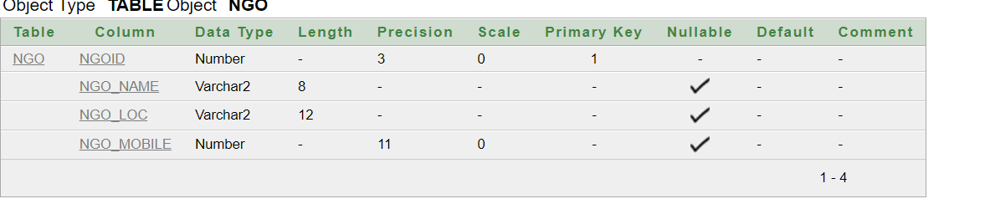
CREATE TABLE RELIEF ORG(
ORGID NUMBER(3) PRIMARY KEY,
ORG_NAME VARCHAR(8),
ORG_LOC VARCHAR (12),
ORG_MOBILE NUMBER(11),
NGOID NUMBER (3),
FOREIGN KEY (NGOID) REFERENCES NGO (NGOID));
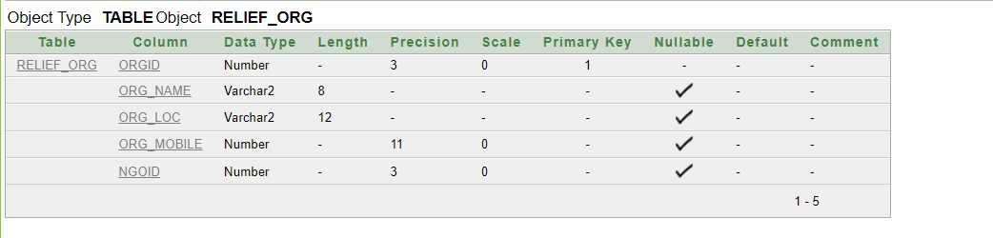
CREATE TABLE IF_FUND(
IFID NUMBER(3) PRIMARY KEY,
IF_NAME VARCHAR(8),
IF_LOC VARCHAR (12),
IF_MOBILE NUMBER(11));
DESC IF_FUND; 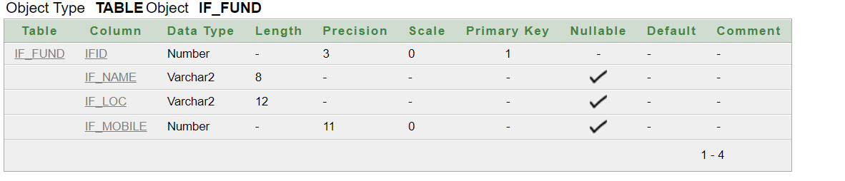
CREATE TABLE PERSON(
PID NUMBER(3) PRIMARY KEY,
P_NAME VARCHAR(8),
P_LOC VARCHAR (12),
P_MOBILE NUMBER(11));
DESC PERSON;
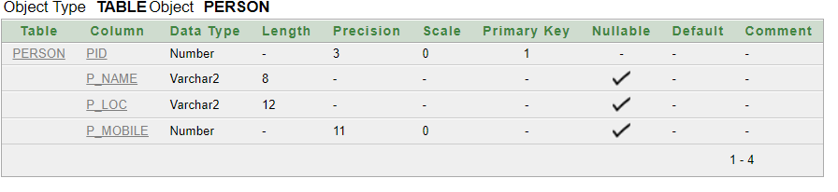
CREATE TABLE FUND_RISER(
FRID NUMBER(3) PRIMARY KEY,
FR_NAME VARCHAR(8));
DESC FUND_RISER;
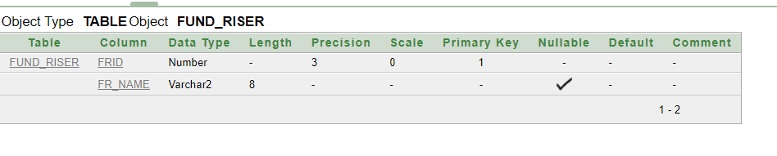
CREATE TABLE GOVT_FUND(
GFID NUMBER(3) PRIMARY KEY,
GF_NAME VARCHAR(8));
DESC GOVT_FUND;
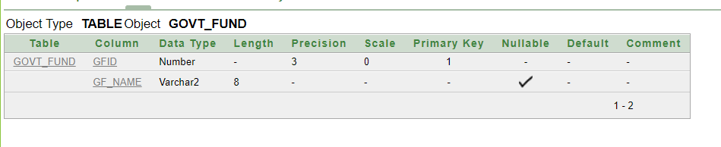
CREATE TABLE IF_AMOUNT(
IFID NUMBER(3) PRIMARY KEY,
IF_AMOUNT NUMBER(8),
NGOID NUMBER(3),
ORGID NUMBER (3),
FOREIGN KEY (NGOID) REFERENCES NGO (NGOID),
FOREIGN KEY (ORGID) REFERENCES RELIEF_ORG (ORGID));
DESC IF_AMOUNT;
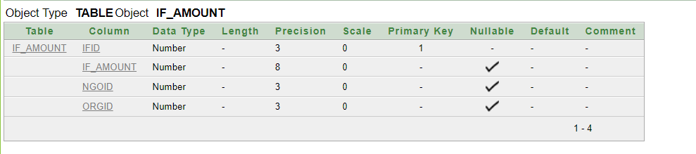
CREATE TABLE PERSON_AMOUNT(
PID NUMBER(3) PRIMARY KEY,
P_AMOUNT NUMBER(8),
NGOID NUMBER(3),
ORGID NUMBER (3),
FOREIGN KEY (NGOID) REFERENCES NGO (NGOID),
FOREIGN KEY (ORGID) REFERENCES RELIEF_ORG (ORGID));
DESC PERSON_AMOUNT;
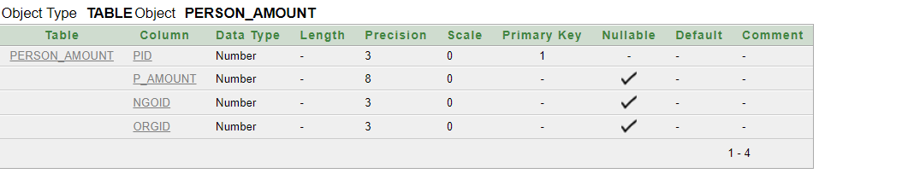
CREATE TABLE FUND_AMOUNT(
FID NUMBER(3) PRIMARY KEY,
F_AMOUNT NUMBER(8),
NGOID NUMBER(3),
ORGID NUMBER (3),
FOREIGN KEY (NGOID) REFERENCES NGO (NGOID),
FOREIGN KEY (ORGID) REFERENCES RELIEF_ORG (ORGID)
);
DESC FUND_AMOUNT;
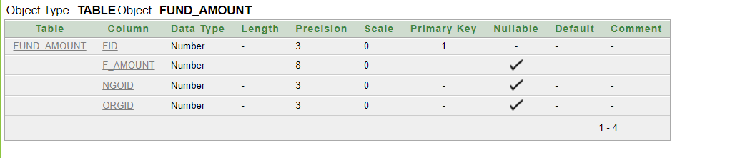
CREATE TABLE GOVT_AMOUNT(
GFID NUMBER(3) PRIMARY KEY,
GF_AMOUNT NUMBER(8),
NGOID NUMBER(3),
ORGID NUMBER (3),
FOREIGN KEY (NGOID) REFERENCES NGO (NGOID),
FOREIGN KEY (ORGID) REFERENCES RELIEF_ORG (ORGID)
);
DESC GOVT_AMOUNT;
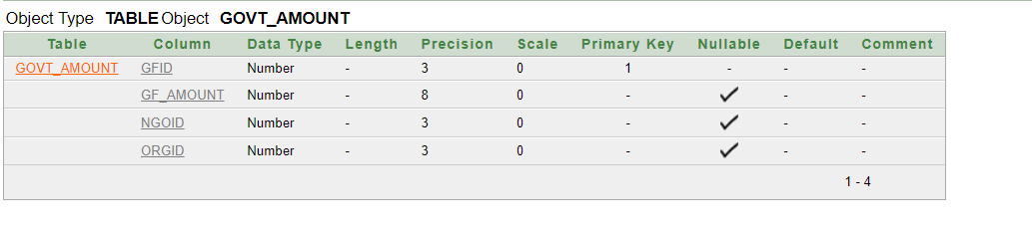

CREATE TABLE FARMER(
FID NUMBER(3) PRIMARY KEY,
F_NAME VARCHAR(8),
F_LOC VARCHAR (12),
F_MOBILE NUMBER(11),
NGOID NUMBER(3),
ORGID NUMBER (3),
FOREIGN KEY (NGOID) REFERENCES NGO (NGOID),
FOREIGN KEY (ORGID) REFERENCES RELIEF_ORG (ORGID));
DESC FARMER;
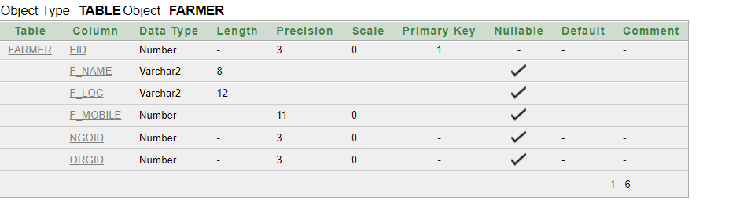
CREATE TABLE NATURE(
NDEID NUMBER(3) PRIMARY KEY,
NDE_NAME VARCHAR(8),
NDE_LOC VARCHAR (12),
NDE_MOBILE NUMBER(11),
NGOID NUMBER(3),
ORGID NUMBER (3),
FOREIGN KEY (NGOID) REFERENCES NGO (NGOID),
FOREIGN KEY (ORGID) REFERENCES RELIEF_ORG (ORGID)
);
DESC NATURE;
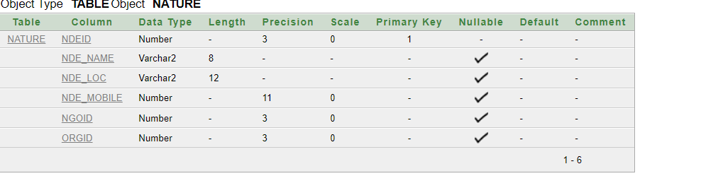

CREATE TABLE ORPHANS(
ORID NUMBER(3) PRIMARY KEY,
OR_NAME VARCHAR(8),
OR_LOC VARCHAR (12),
OR_MOBILE NUMBER(11),
NGOID NUMBER(3),
FOREIGN KEY (NGOID) REFERENCES NGO (NGOID));
DESC ORPHANS; 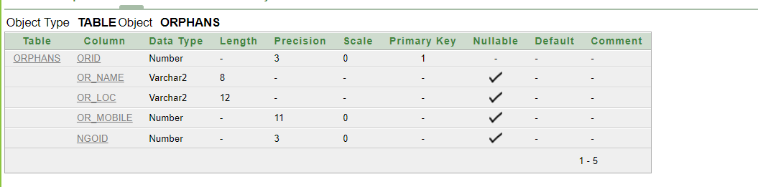
CREATE TABLE DISABLE(
DISID NUMBER(3) PRIMARY KEY,
DIS_NAME VARCHAR(8),
DIS_LOC VARCHAR (12),
DIS_MOBILE NUMBER(11),
NGOID NUMBER(3),
FOREIGN KEY (NGOID) REFERENCES NGO (NGOID));
DESC DISABLE;
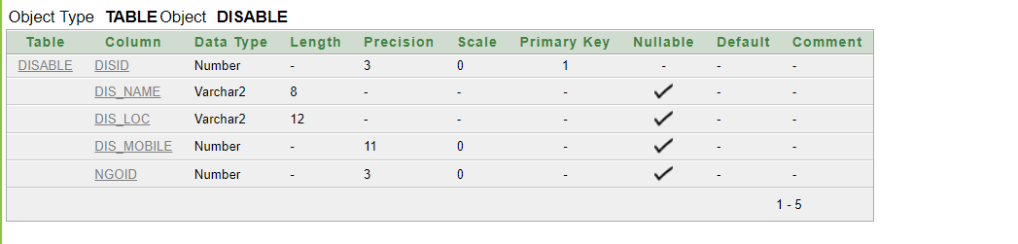
CREATE TABLE MATERNITY (
MATID NUMBER(3) PRIMARY KEY,
MAT_NAME VARCHAR(8),
MAT_LOC VARCHAR (12),
MAT_MOBILE NUMBER(11),
NGOID NUMBER(3),
FOREIGN KEY (NGOID) REFERENCES NGO (NGOID));
DESC MATERNITY ;
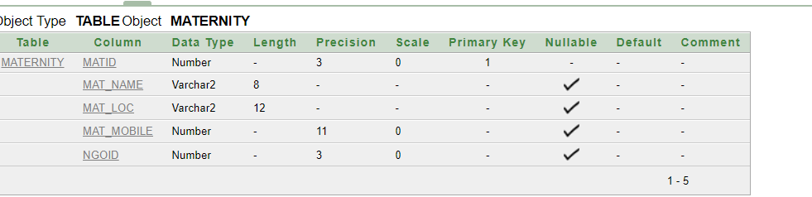

INSERT VALUES

INSERT INTO NGO
VALUES (01,'ASA','DHAKA',01700000001);
INSERT INTO NGO
VALUES (02,'BRAC','RAJ',01700000002);
INSERT INTO NGO
VALUES (03,'DDL','CU',01700000003);
INSERT INTO NGO
VALUES (04,'GP','DA',01700000004);
INSERT INTO NGO
VALUES (05,'BL','BR',01700000005);
SELECT *
FROM NGO;
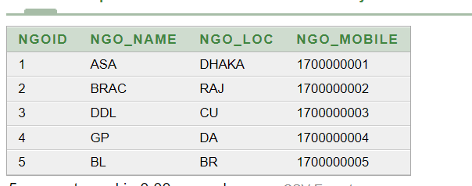
INSERT INTO RELIEF_ORG
VALUES (11,'JAAGO','DHAKA',0170000011,1);
INSERT INTO RELIEF_ORG
VALUES (12,'ACTION','FENI',0170000021,2);
INSERT INTO RELIEF_ORG
VALUES (13,'BINNAS','KU',0170000031,3);
INSERT INTO RELIEF_ORG
VALUES (14,'BANCAT','CU',0170000041,4);
INSERT INTO RELIEF_ORG
VALUES (15,'HUMANITY','CH',0170000051,5);
SELECT *
FROM RELIEF_ORG;
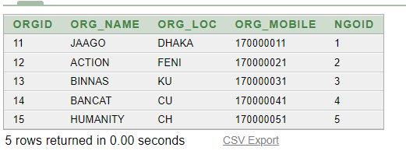
INSERT INTO IF_FUND
VALUES (31,'BBC','USA',70000011);
INSERT INTO IF_FUND
VALUES (32,'VOX','CAD',70000411);
INSERT INTO IF_FUND
VALUES (33,'ALNAS','UAE',70000511);
INSERT INTO IF_FUND
VALUES (34,'HH','USA',70006011);
INSERT INTO IF_FUND
VALUES (35,'BC','UK',70070011);
SELECT *
FROM IF_FUND;
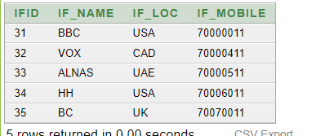
INSERT INTO PERSON
VALUES (41,'KAMAL','UK',75000011);
INSERT INTO PERSON
VALUES (42,'JAMAL','DHAKA',75000011);
INSERT INTO PERSON
VALUES (43,'ALOM','BR',75000011);
INSERT INTO PERSON
VALUES (44,'OLI','RN',75800011);
INSERT INTO PERSON
VALUES (45,'RIHAN','CU',75000011);
SELECT *
FROM PERSON;
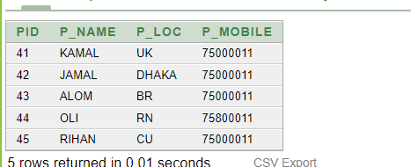
INSERT INTO FUND_RISER
VALUES (55,'SA');
INSERT INTO FUND_RISER
VALUES (56,'GP');
INSERT INTO FUND_RISER
VALUES (57,'BL');
INSERT INTO FUND_RISER
VALUES (58,'ROBI');
INSERT INTO FUND_RISER
VALUES (59,'BBS');
SELECT *
FROM FUND_RISER;
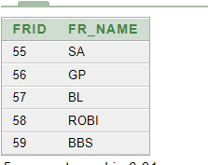
INSERT INTO GOVT_FUND
VALUES (75,'JONATA');
INSERT INTO GOVT_FUND
VALUES (76,'ISLAMIA');
INSERT INTO GOVT_FUND
VALUES (77,'DBL');
INSERT INTO GOVT_FUND
VALUES (78,'PUBALI');
SELECT *
FROM GOVT_FUND;
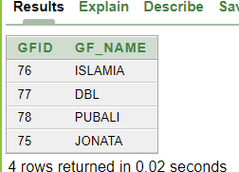
INSERT INTO IF_AMOUNT
VALUES (121,320000,1,11);
INSERT INTO IF_AMOUNT
VALUES (122,520000,2,12);
INSERT INTO IF_AMOUNT
VALUES (123,620000,3,13);
INSERT INTO IF_AMOUNT
VALUES (124,720000,4,14);
INSERT INTO IF_AMOUNT
VALUES (125,70000,5,15);

SELECT *
FROM IF_AMOUNT;
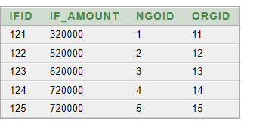
INSERT INTO PERSON_AMOUNT
VALUES (41,720000,1,11);
INSERT INTO PERSON_AMOUNT
VALUES (42,20000,2,12);
INSERT INTO PERSON_AMOUNT
VALUES (43,780000,3,13);
INSERT INTO PERSON_AMOUNT
VALUES (44,720400,4,14);
SELECT *
FROM PERSON_AMOUNT;
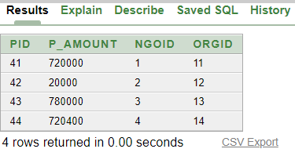
INSERT INTO FUND_AMOUNT
VALUES (91,990400,1,11);
INSERT INTO FUND_AMOUNT
VALUES (92,999400,2,12);
INSERT INTO FUND_AMOUNT
VALUES (93,990409,3,13);
INSERT INTO FUND_AMOUNT
VALUES (94,980400,4,14);
INSERT INTO FUND_AMOUNT
VALUES (95,999400,5,15);
SELECT *
FROM FUND_AMOUNT;
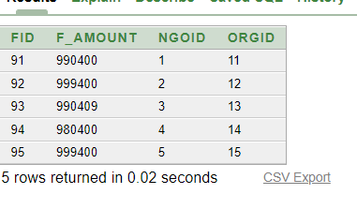
INSERT INTO GOVT_AMOUNT
VALUES (75,999400,1,11);
INSERT INTO GOVT_AMOUNT
VALUES (76,9400,2,12);
INSERT INTO GOVT_AMOUNT
VALUES (77,999488,3,13);
INSERT INTO GOVT_AMOUNT
VALUES (78,999800,4,14);
INSERT INTO GOVT_AMOUNT
VALUES (79,999800,5,15);

SELECT *
FROM GOVT_AMOUNT;
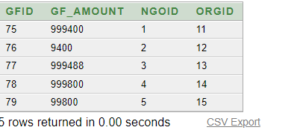

INSERT INTO FARMER
VALUES (91,'FARUK','DANKHALI',0178686,1,11);
INSERT INTO FARMER
VALUES (92,'RUK','DANALI',01780686,2,12);
INSERT INTO FARMER
VALUES (93,'ASRUK','DHALI',01786806,3,13);
INSERT INTO FARMER
VALUES (94,'RAKIB','NOLI',01786860,4,14);
INSERT INTO FARMER
VALUES (95,'KJRUK','KUMKHALI',017080686,5,15);
SELECT *
FROM FARMER;
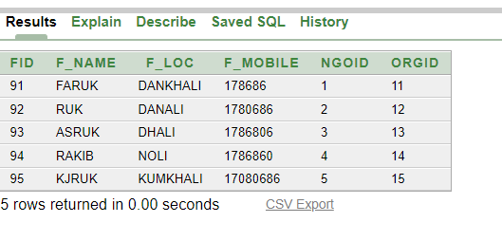
INSERT INTO NATURE
VALUES (101,'CYCLON','SEN',017080686,1,11);
INSERT INTO NATURE
VALUES (102,'FLAT','RAJ',017079876,2,12);
INSERT INTO NATURE
VALUES (103,'MOKHA','COX',0170806089,3,13);
INSERT INTO NATURE
VALUES (104,'TEMP','CUMIL',017000086,4,14);
INSERT INTO NATURE
VALUES (105,'KHORA','DHAKA',0170807656,5,15);
SELECT *
FROM NATURE;
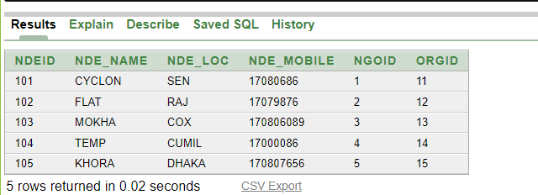
INSERT INTO ORPHANS
VALUES (106,'KARIM','DHDKA',01707656,1);
INSERT INTO ORPHANS
VALUES (107,'SAGOR','FENI',0170007656,2);
INSERT INTO ORPHANS
VALUES (108,'RIM','DIN',0170154656,3);
INSERT INTO ORPHANS
VALUES (109,'TANIM','BOGURA',01707656,4);
INSERT INTO ORPHANS
VALUES (110,'ARIMA','KUM',01707656,5);
SELECT *
FROM ORPHANS;
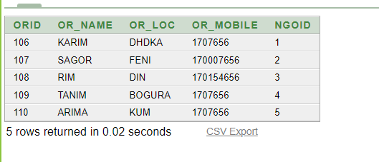
INSERT INTO DISABLE
VALUES (111,'ASRIMA','RU',0130987,1);
INSERT INTO DISABLE
VALUES (112,'SARUL','KKR',013098700,2);
INSERT INTO DISABLE
VALUES (113,'VRIT','RCB',013021987,3);
INSERT INTO DISABLE
VALUES (114,'DHONI','CSK',0190130987,4);
INSERT INTO DISABLE
VALUES (115,'ROHIT','MI',014430987,5);
SELECT *
FROM DISABLE;
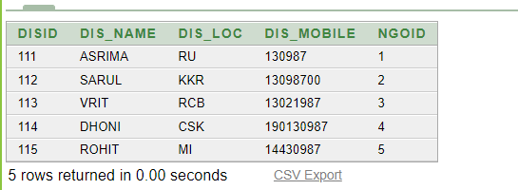
INSERT INTO MATERNITY
VALUES(MATID.NEXTVAL,'MINA','DHAKA',01755667788,1);
INSERT INTO MATERNITY
VALUES(MATID.NEXTVAL,'RINA','FENI',01755655788,2);
INSERT INTO MATERNITY
VALUES(MATID.NEXTVAL,'ALO','RANGPUR',01755667799,3);
INSERT INTO MATERNITY
VALUES(MATID.NEXTVAL,'MILA','BOGURA',01755688788,4);
INSERT INTO MATERNITY
VALUES(MATID.NEXTVAL,'NILA','BARISHAL',01855667788,1);

SELECT *
FROM MATERNITY;
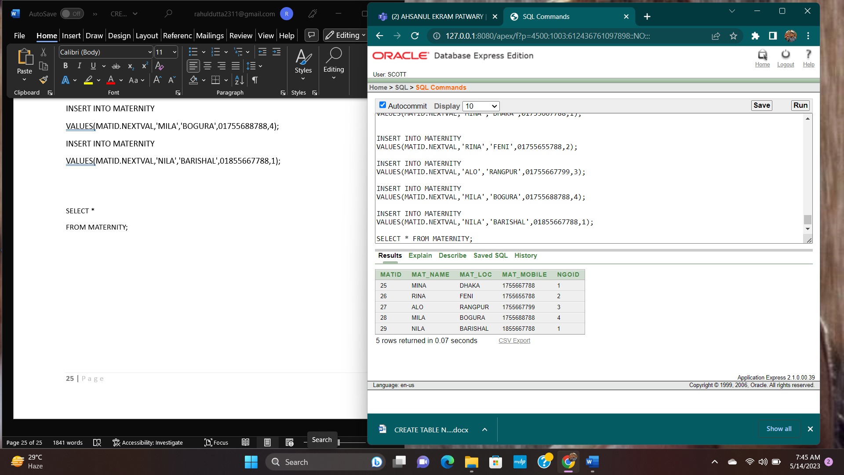

From group function:
1.Determine and show the maximum amount, minimum amount and average amount from the GF_AMOUNT TABLE.
Answer:

SELECT MAX(GF_AMOUNT) "MAXIMUM AMOUNT ",MIN(GF_AMOUNT)
"MINIMUM AMOUNT ",ROUND(AVG(GF_AMOUNT)) "AVARAGE AMOUNT"
FROM GOVT_AMOUNT;
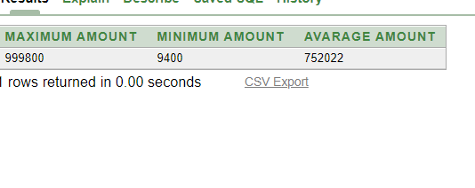
2.Show ID of RAKIB from the table FARMER.
Answer:
SELECT F_NAME,FID
FROM FARMER
WHERE LOWER(F_NAME) = 'rakib';
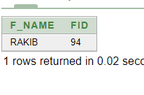
FROM SUB-QUERY:

      - Show the name of the person which P_LOC has higher P_LOC than the P_LOC DHAKA.
Answer:
SELECT P_NAME,P_LOC
FROM PERSON
WHERE P_LOC>
( SELECT P_LOC
FROM PERSON
WHERE P_LOC='DHAKA'
);
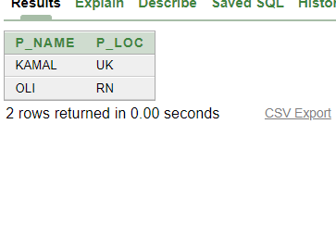
      - Display the first maximum AMOUNT from IF_AMOUNT
Answer:

SELECT MAX(IF_AMOUNT)
FROM IF_AMOUNT;
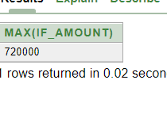

- Display the 2nd maximum AMOUNT from IF_AMOUNT
Answer:
SELECT MAX(IF_AMOUNT)
FROM IF_AMOUNT
WHERE IF_AMOUNT< (SELECT MAX(IF_AMOUNT)FROM IF_AMOUNT);

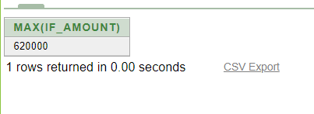

From view:
1.Create a view by using P_NAME, PID,P_LOC column from the ‘PERSON’ table.
Answer:
CREATE VIEW P10
AS SELECT P_NAME,PID,P_LOC
FROM PERSON;

SELECT * FROM P10;

